August 16th, 2009
Hi
Again, not much to write about!
I have been feeling rather tired, probably due, as I have mentioned before, to the need to get the drafts for all the four Indonesia primary books done by the end of August. I should be able to do it as I have just over one chapter to do out of a total of 48 chapters. However, for the P6 book, the chapters are more difficult to write. Sometimes, when the material is the same as I used for the Brunei primary books a few years ago, the writing is speeded up. But the chapter I have left until last I have to do from scratch. I sometimes wonder why I agreed to do these books, as the market will be very small; only a few selected primary schools will be switching to using English as the medium of instruction. I do not know if I mentioned that the Brunei books will no longer be used as Brunei has a new syllabus and have also opened up the market to all publishers. (Because Brunei is so small, their previous policy was to tender out the writing then select just one.) Also, with the change in the structure of secondary education in HK, I will have no more books in use. This textbook writing business is a matter of just running to stay in the one spot!

In spite of tiredness, I still did exercise. I even did a total of 6 km swimming (over three days). The strange thing is I do not feel tired while actually swimming and could keep doing more if I wanted to. For example, I was only going to do 1.4 km on Friday (to give 5 km for the week) but kept on going and did 2.4 km.
I went to the dermatologist the other morning. Again, no action. Will go again in December. There is one issue though. I seem to get a regular scratch on my nose below a previous BCC area. However, it always clots and heals.
The number of official H1N1 cases in HK is over 8000 now and there have been four deaths (I think). The main articles in this week’s TIME magazine are about swine flu. And I think I have the answer to the question I asked a few weeks ago about vaccines. Medicines such as ‘Tamiflu’ are not ‘vaccines’ but are ‘anti-viral drugs’. So their effect is to damage the virus cells so that they cannot reproduce rather than stimulating the production of antibodies as a vaccine does. So why people in HK (?and elsewhere) keep referring to them as vaccines I don’t know.
I have just heard on the radio news that the final link in the West rail line opened this morning. You are familiar with the East rail line, which is the one from Hunghom (and now East Tsim Sha Tsui) past CU to the border. I do not know if you have used the West rail line but it is the one that passes through Tin Shui Wai and ends in the Mongkok area. (You might have been aware of all the construction that was going on for this link under the roads around the YMCA area.) The final link connects this station with the East Tsim Sha Tsui station. Because of this, I may use it more often instead of taking the hotel bus to TST as it should be quicker and cheaper. However I have not actually been to TST for over six months!!

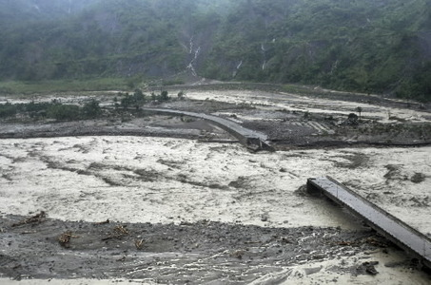
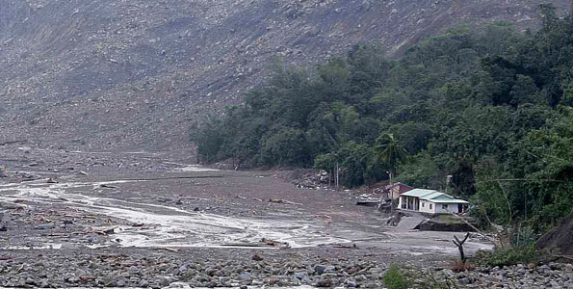
You have probably heard about the damage and loss of life caused by the recent typhoon across that passed across Taiwan and the coast of China. In Taiwan, hundreds were buried under mudslides caused by the rain; not as many as originally feared but still hundreds. (In the left-hand photo, only two houses remain form a whole village that was buried buy mud).
That seems to all for now.

Cheers

